COMMUNITY PARTNERSHIP – HELPING US
Transforming lives for good.
THANK YOU!!
Under Construction -
Hervey Bay - Pialba

Hervey Bay Boat Club - Urangan
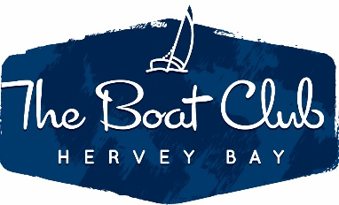
9 Main St, Pialba QLD 4655 -
Ph (07) 4124 1115

www.baysidechristianchurch.com.au
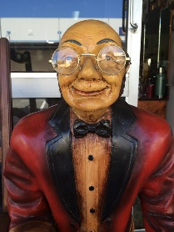

WIDE BAY ANTIQUES – Main Street Pialba
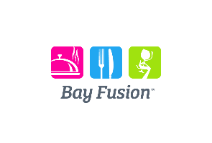

CATERING – www.bayfusion.com.au

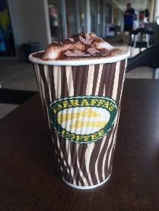

Zarrafas – Woolworths Carpark - Pialba - www.zarraffas.com

Torquay Terrace – Pialba – Phone 0402 600 606

1b/101 Beach Rd, Pialba QLD 4655
(07) 4194 2564

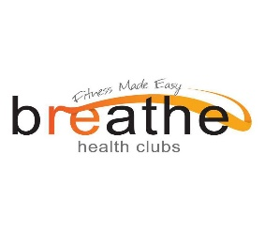
184 Dayman St, Urangan QLD 4655
(07) 4128 9355

